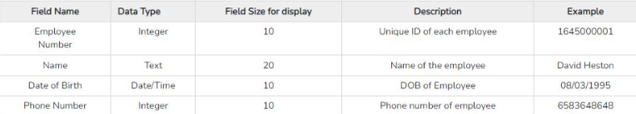

Active Data dictionary

If the structure of the database or its specifications change at any point of time, it should be reflected in the data dictionary. This is the responsibility of the database management system in which the data dictionary resides.

So, the data dictionary is automatically updated by the database management system when any changes are made in the database. This is known as an active data dictionary as it is self-updating.

Passive Data Dictionary

This is not as useful or easy to handle as an active data dictionary. A passive data dictionary is maintained separately to the database whose contents are stored in the dictionary. That means that if the database is modified the database dictionary is not automatically updated as in the case of Active Data Dictionary.

So, the passive data dictionary must be manually updated to match the database. This needs careful handling or else the database and data dictionary are out of sync.

Data dictionary is like a database about a database. Data dictionaries are used by system designers to plan information. They describe:

* Contents
* Format
* Structure of a database
* Relationship between its entities or objects

Typically, a data dictionary will:

* Include the names and descriptions and the fields contained in each table
* Record information about the data type, length of each field
* Validation to be used

The purpose of a data dictionary is to provide the implementation team with enough information to allow them to develop the system.

There is no set standard about layout or level of detail. It is generally accepted that data dictionaries should provide enough information to allow a third party to program or implement the system without prior knowledge of it.

Example:

